Ch 16. Hemp Canker

Kingdom: | Fungi | Fungi | Fungi | Fungi | Fungi
Phylum: | Ascomycota | Ascomycota | Ascomycota | Ascomycota | Ascomycota
Class: | Leotiomycetes | Dothideomycetes | Dothideomycetes | Dothideomycetes | Sordariomycetes
Order: | Helotiales | Pleosporomycetidae | Pleosporomycetidae | Capnodiales | Hypocreales
Family: | Sclerotiniaceae | Didymellaceae | Didymellaceae | Davidiellaceae | Nectriaceae
Genus: | Sclerotinia | Phoma | Ascochyta | Cladosporium | Fusarium
Species: | S. sclerotiorum & S. minor | P. cannabis, P. exigua, P. glomerata, P. herbarum, P. piskorzii, P. nebulosa | A. cannabina, A. arcuata | C. herbarum, C. resinae, C. tenuissiumum, C. cladosporioides | F. sulphureum, F. avenaceum, F. sulphurem, F. graminearum.

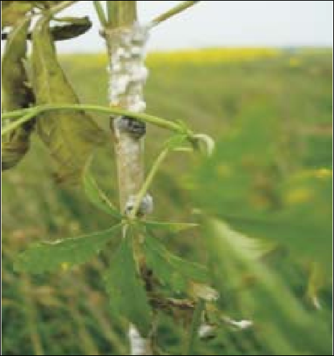
Figure 16.1. Sclerotinia sclerotiorum growing on Cannabis indica in India (Sharma et al. 2016).
Introduction
Hemp Canker is a disease typically caused by Sclerotinia sclerotiorum or S. minor. These fungi can infect over 350 different species of crops from a diversity of plant families. Purdy considers S. sclerotiorum one of the most nonspecific, omnivorous, and successful of all plant pathogens (Purdy, 1979). This pathogen broadley affects Cannabis gene pools (Sharma et al. 2016).
Diseases caused by S. sclerotiorum are also known as cottony rot, watery soft rot, stem rot, drop, crown rot, blossom rot, and probably other names as well. Many other fungal species can cause canker infections on Cannabis, though it is most commonly caused by S. sclerotiorum.
A canker is simply a name given to a disease expression that is caused by any number of bacteria or fungi. The symptoms typically include a lesion on the stem that can be irregular and sunken, swollen, flattened and/or cracked. Hemp canker on Cannabis is usually first detected by white mycelium growing on the stem, often near nodes, that can later produce small black sclerotia. This can girdle the stems, thus killing the plant entirely. Unfortunately, by the time this pathogen is detected, usually it is too late to save the affected plant. Sometimes, the fungus grows within the pith of Cannabis, presenting as a wilt before fungus is obvious on the outside of the stem.

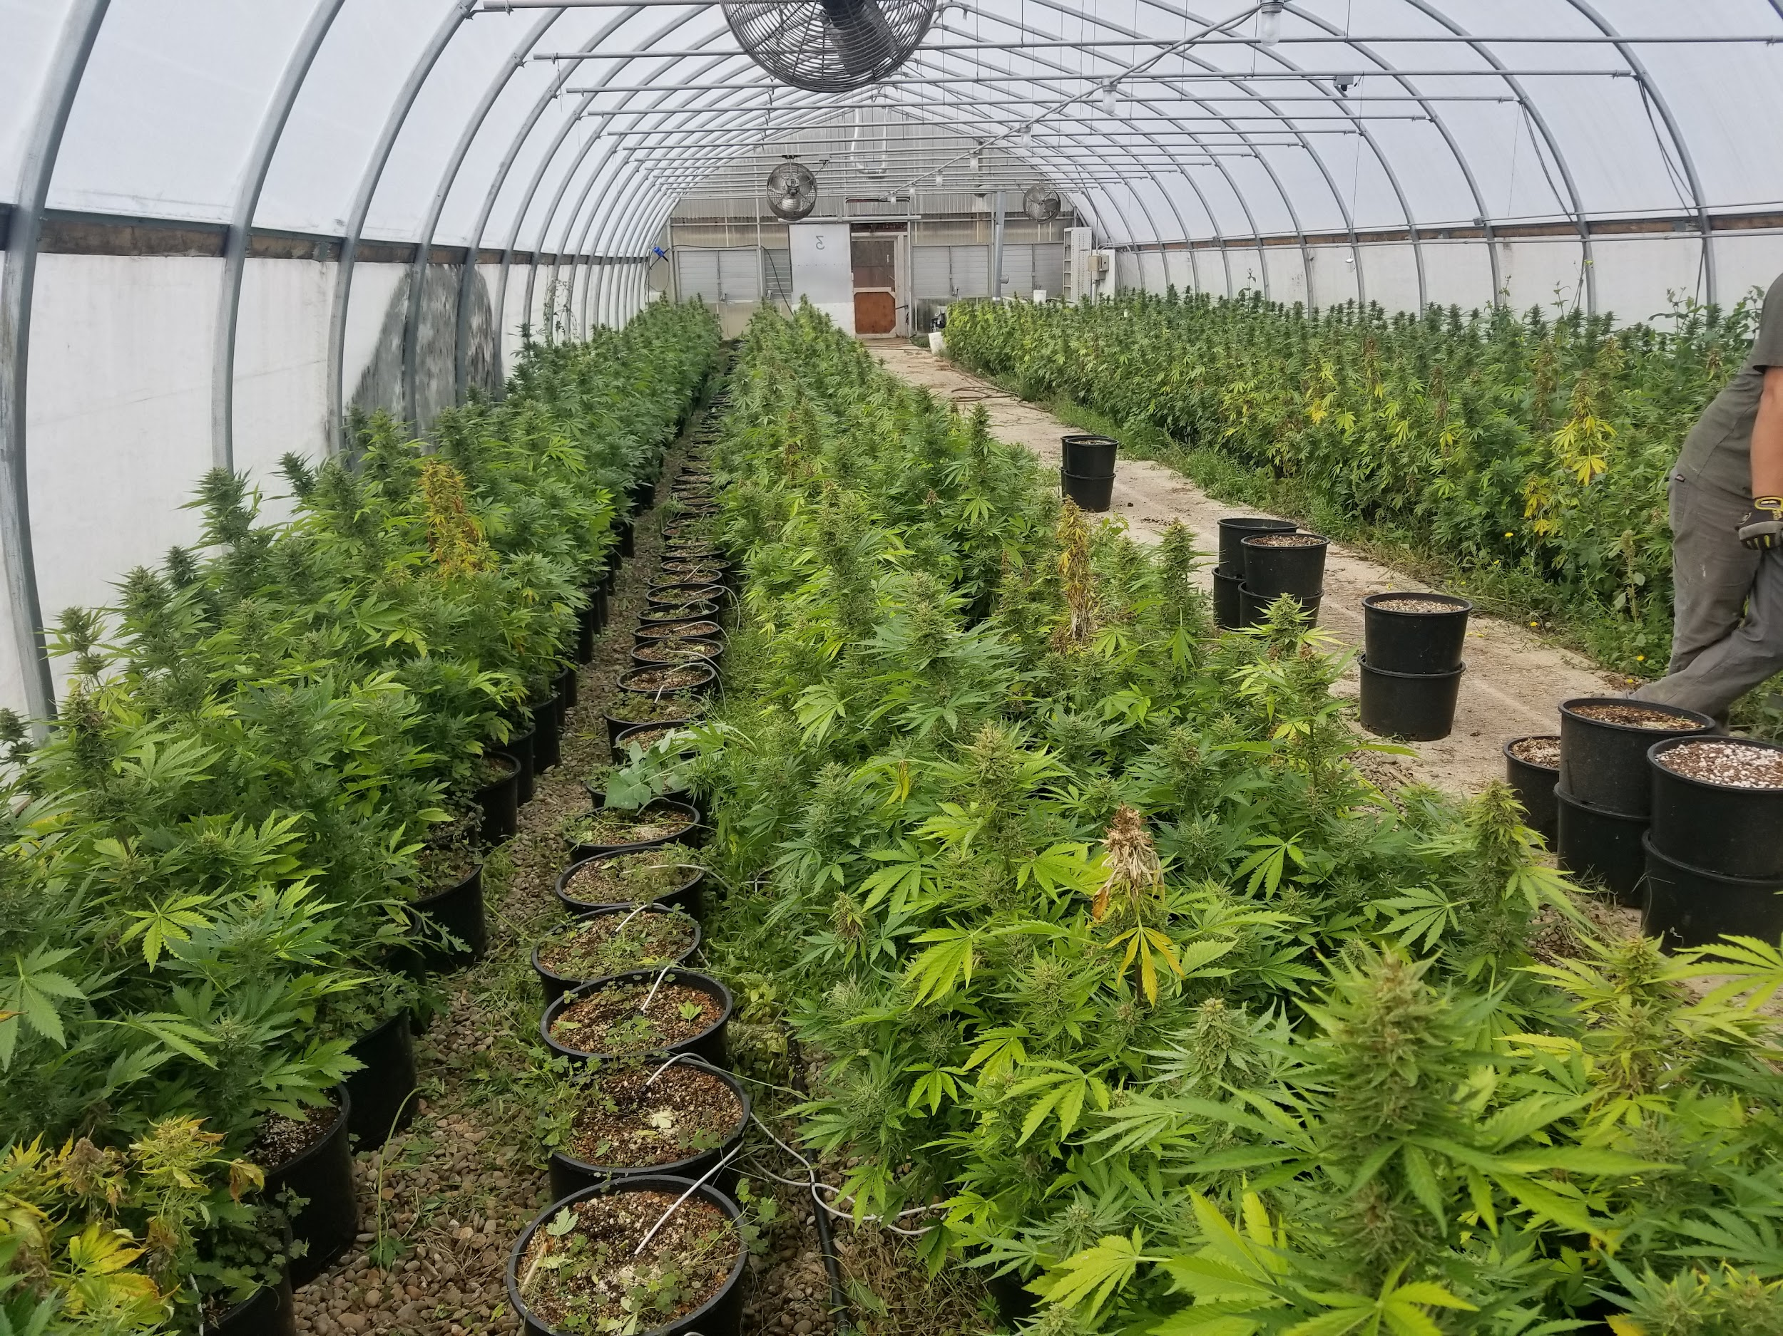
Figure 16.2 The dead tops that can be seen throughout this greenhouse were caused by S. sclerotiorum girdling the stem from within. Sclerotia were formed inside the stem within the pith.

Biology & Lifecycle
Sclerotinia sclerotiorum and Sclerotinia minor are ascomycetes within the family Sclerotiniaceae, occupied by many other plant parasites, including Botrytis. Sclerotina are necrotrophic pathogens; capable of growing saprophytically, but are weak competitors. However, like Botrytis, when they infect living hosts they require senescing host plant tissue to colonise and mount a necrotrophic attack. Once established as a weak saprophyte on dead or dying host tissue, Sclerotinia attempts an enzymatic assault on nearby living host tissue in order to actively kill and consume it. These fungi produce an array of extracellular enzymes, including oxalic acid (a known virulence factor of plant pathogens), to damage and weaken the host cells prior to infection (Petrofeza and Nasser 2012).
Growth first appears as white cottony mycelial growth before forming hardened black structures (sclerotia). Mycelial growth and sclerotia formation may occur covertly within the stem, usually killing the plant above the diseased area. Sclerotinia spp. disseminate via windborne ascospores produced in mushroom-like apothecia similar to Botryotinia (grey mold). Unlike Botryotinia, the sexual stage of the asexual Botrytis, Sclerotinia does not have a cooresponding asexual stage. Therefore, within canopy disease amplification does not occur, rather infections represent unique isolates originating from apothecia in the environment, or soil borne infections.
Sclerotinia is a homothallic ascomycete, meaning it is capable of sexual reproduction through self fertilization. Sclerotia, which are stone-like, hardened, melanized hyphal structures that look like hardened bits of charcoal (Figure 15.3), are produced during the growing season within or on their previous plant host. Sclerotinia produces these structures to overwinter in the soil or in host plant debris at rest until the environment becomes favorable to growth again. When environmental conditions are favorable, fruiting bodies arise directly from the previous seasons sclerotia to produce sexual, wind- (or occasionally insect-) dispersed ascospores. Sclerotia may also germinate vegetative hyphae and grow through the soil to infect physically proximate plants asexually, even though no asexual spores are produced.
Sclerotinia can grow in a wide variety of environmental conditions, which helps make it so successful. Although this fungus prefers cool, moist climates, it has also been documented in hot dry areas as well and has been shown to grow from 0-32oC, with impeded growth nearing either extreme (Purdy, 1979).

Prevention and Treatment
Sclerotinia are widely dispersed pathogens with wide host species ranges. Specific infection sources may be shared equipment and sclerotia in seed lots. The seed coat of seed itself may also harbor infective Sclerotina (Sharma et al., 2016). Antifungal seed treatments should be used for seed suspected of harboring pathogens (see chapter on Botrytis).
Sclerotinia sp. thrive in high moisture environments. Sclerotia are dependent on moisture to break their dormancy. Excessive field moisture is positively associated with disease incidence (Abawi and Grogan 1979). Deep plowing (with care not to spread disease via implements) and the incorporation of organic materials can decrease sclerotia survival (Mueller et al. 2002). Prolonged flooding (3-5 weeks) may also be effective for heavily infested fields (Steadman 1979). However, Steadman also noted that subsequently ensuring well drained soil during the growing season is key for limiting disease pressure. Long crop rotations (3+ years) with cereal crops or other non-host plants can reduce inoculum density, though sclerotia may survive in dormancy for many years. Microbial treatments, including Trichoderma viride (Pankaj et al 2011) and combinations of Pseudomonas aeruginosa, Trichoderma harzianum and Bacillus subtilis (Jain et al, 2015) were effective at reducing disease incidence and improving plant vigor in the presence of Sclerotinia.

